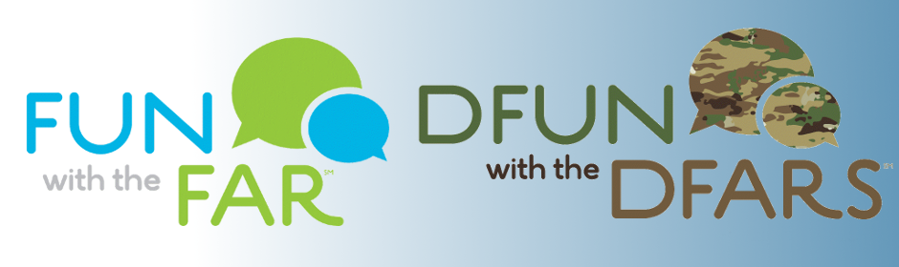

Combined Schedule for Fun with the FAR Season 6 &

DFun with the DFARS

2018-2019
N.B.: all FAR sessions are on Wednesdays from noon to 1:30, and all DFARS sessions are on Tuesdays from 1 to 2:40
October 3: FAR Session 1: Parts 1 and 2

October 9: DFARS Session 1: Parts 201, 202, 252.1, 203, and 204
October 17: FAR Session 2: Part 3

October 31: FAR Session 3: Parts 5 and 6

November 6: DFARS Session 2: Parts 205, 206, 207, 208, 209, 210, and 211

November 14: FAR Session 4: Parts 7, 10, and 11

November 28: FAR Session 5: Parts 8, 38, 39, and 51

December 4: DFARS Session 3: Parts 212, 213, 214, 215.1 through 215.3, and 244

December 12: FAR Session 6: Parts 4 and 24

December 19: FAR Session 7: Parts 12 and 13

January 8: DFARS Session 4: Parts 216, 217, and 218

January 9: FAR Session 8: Parts 9 and 14

January 23: FAR Session 9: Part 15

February 5: DFARS Session 5: Parts 215.4, 230, 231, and 232

February 6: FAR Session 10: Part 15.4
February 20: FAR Session 11: Part 16

March 5: DFARS Session 6: Parts 219, 222, 223, and 226

March 6: FAR Session 12: Parts 17 and 18

March 20: FAR Session 13: Parts 19 and 26

April 2: DFARS Session 7: Part 225

April 3: FAR Session 14: Parts 22 and 23

April 17: FAR Session 15: Part 25
May 1: FAR Session 16: Part 27

May 7: DFARS Session 8: Parts 224, 227, 228, and 229

May 15: FAR Session 17: Parts 28 and 29

May 29: FAR Session 18: Parts 30, 31, and 32

June 4: DFARS Session 9: Parts 234, 235, 236, 237, 239, and 241

June 12: FAR Session 19: Part 33

June 26: FAR Session 20: Parts 34 and 35
July 9: DFARS Session 10: Parts 233, 234, 236, 237, 239, 241

July 10: FAR Session 21: Parts 36, 37, 41, and 48

July 24: FAR Session 22: Parts 42 and 43

August 6: DFARS Session 11: Parts 233, 249, and 250

August 7: FAR Session 23: Part 44

August 28: FAR Session 24: Parts 45, 46, and 47

September 3: DFARS Session 12: Parts 252.2 and 253

September 11: FAR Session 25: Part 49

September 25: FAR Session 26: Parts 50, 51, and 52

